Set Up a Web Application on Amazon EC2
Name: More Sanjivani Rameshwar
PRN NO: 2124UCSF1115

1. Objective
To launch a virtual server on Amazon EC2, secure it with a Security Group that allows SSH (port 22) only from my IP and HTTP (port 80) for public access, connect to it over SSH, install the Nginx web server, deploy a simple HTML web application, and verify it in a web browser.

2. Architecture
User Browser → Internet → Security Group (ports 22, 80) → EC2 Instance (Ubuntu) → Nginx → index.html
Component | Role
EC2 instance | Virtual server hosting the application
Key pair (.pem) | Private key for secure SSH authentication
Security Group | Virtual firewall controlling inbound and outbound traffic
Nginx | Web server listening on port 80
index.html | The deployed web application

3. Step 1: Launch an EC2 Instance
- Signed in to the AWS Management Console, opened EC2, and clicked Launch instance.
- Name: my-web-server
- AMI: Ubuntu Server 24.04 LTS (Free tier eligible)
- Instance type: t2.micro / t3.micro
- Key pair: created my-ec2-key (RSA, .pem format) and stored it safely.
- Storage: default 8 GB gp3.
- Clicked Launch instance.
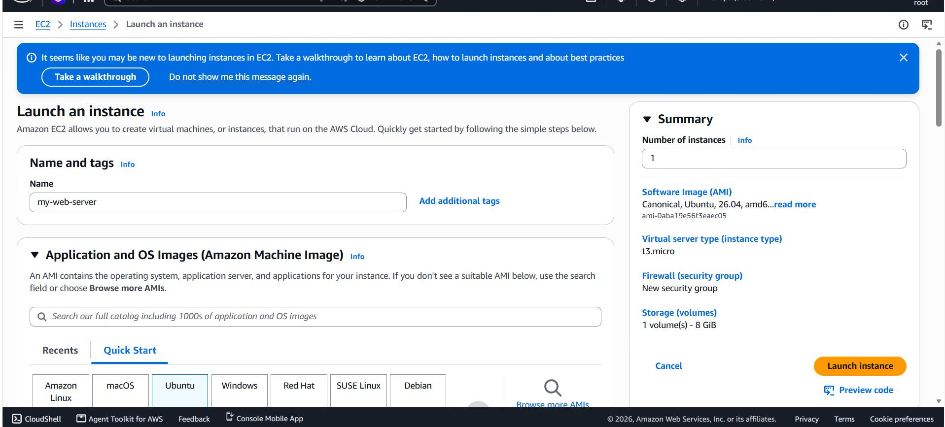
Figure 1: Launch instance screen in the EC2 console

Step 2: Configure the Security Group
A security group named web-server-sg was configured with these inbound rules:
Type | Protocol | Port | Source | Purpose
SSH | TCP | 22 | My IP | Admin access only from my machine
HTTP | TCP | 80 | 0.0.0.0/0 | Public web access
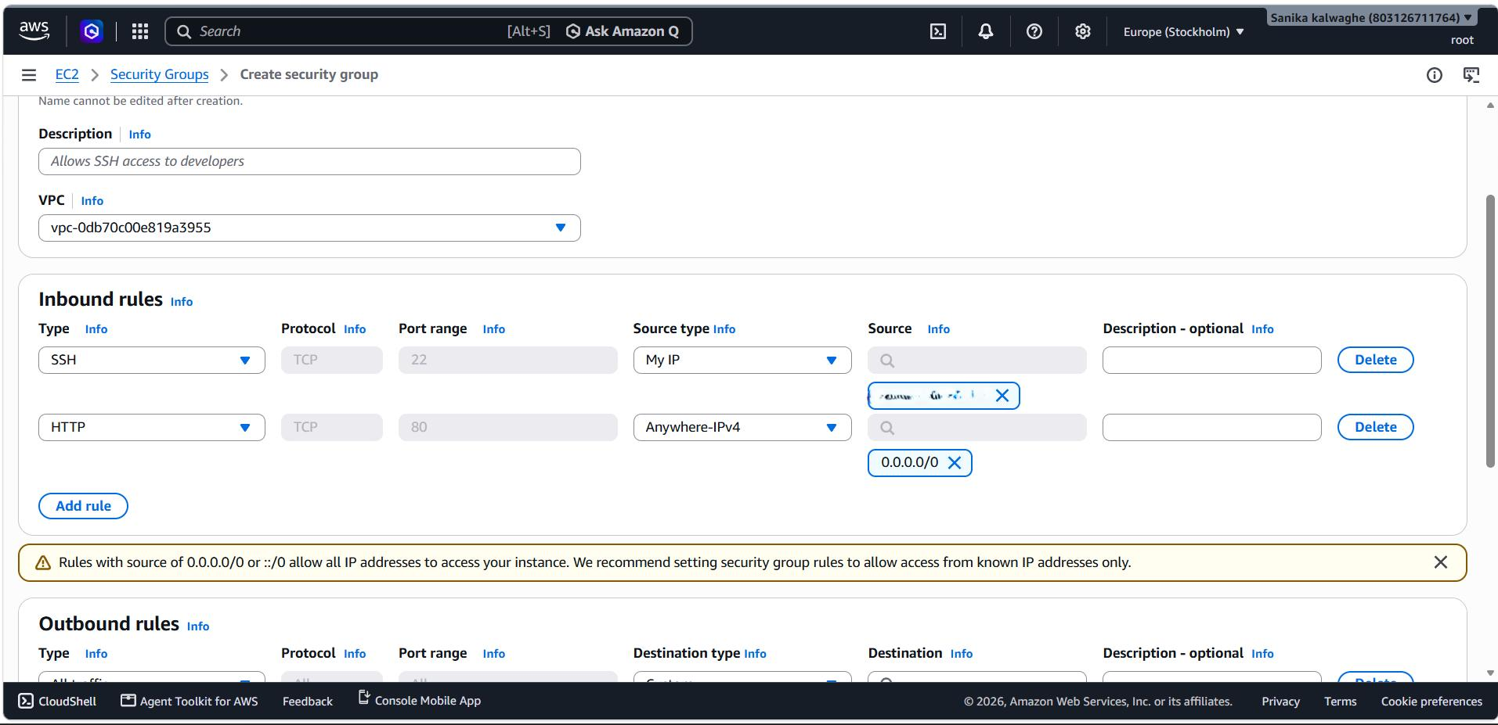
Figure 2: Inbound rules in the Create security group screen

Step 3: Connect to the Instance via SSH
Command run from Windows PowerShell:
ssh -i "C:\Users\Asus\Downloads\my-ec2-key.pem" ubuntu@ip

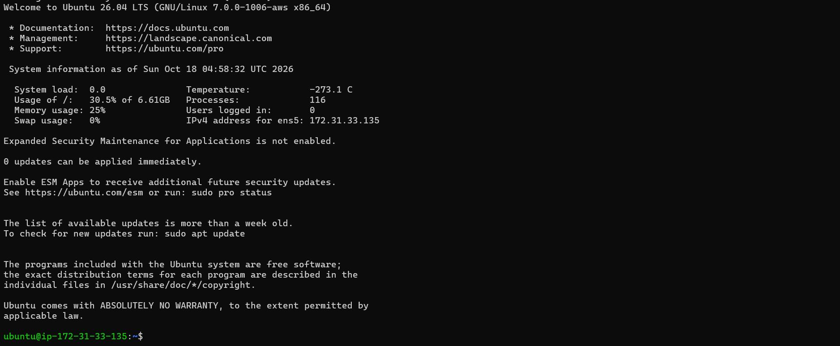
Figure 3: Successful SSH login to the Ubuntu instance

Step 4: Install and Configure Nginx
sudo apt update && sudo apt upgrade -y
sudo apt install nginx -y
sudo systemctl start nginx
sudo systemctl enable nginx
sudo systemctl status nginx

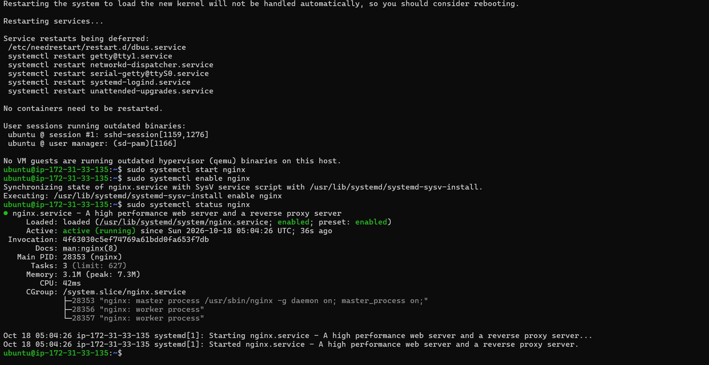
Figure 4: Nginx service running (systemctl status nginx)

Step 5: Deploy a Simple HTML Web Application
cd /var/www/html
sudo mv index.nginx-debian.html index.nginx-debian.html.bak
sudo nano index.html

Contents of index.html
<!DOCTYPE html>
<html lang="en">
<head>
<meta charset="UTF-8">
<meta name="viewport" content="width=device-width, initial-scale=1.0">
<title>My EC2 Web App</title>
<style>
body { font-family: Arial, sans-serif; background: #f0f4f8; text-align: center; padding-top: 80px; }
h1 { color: #232f3e; }
p { color: #555; }
.badge { display: inline-block; background: #ff9900; color: #fff; padding: 8px 16px; border-radius: 6px; }
</style>
</head>
<body>
<h1>Hello from Amazon EC2!</h1>
<p>This web application is hosted on an Ubuntu EC2 instance using Nginx.</p>
<span class="badge">Deployed by: Dhanashree Suresh Madhavai</span>
</body>
</html>


Figure 5: The deployed web application in the browser

Conclusion
An EC2 instance was launched, secured with a least-privilege Security Group, accessed over key-based SSH, configured with the Nginx web server, and used to host a simple HTML application reachable from a browser. The exercise covered virtual servers, network security, remote administration and web deployment, along with practical troubleshooting of connectivity problems.

